Name: Lucas Pereira Silva

Computer Application

Assignment #3 – Excel Charts

Introduction - Make use of Excel charts, i.e., Spark line, tabular, pie chart. You can take dummy data for your results. Make sure to generate a visual chart display using multiple tabs.

First of all, it was a simple project, showing the importance of data becoming chart to more detail of information.

Methodology

First Sheet:

1- On the first sheet, I was supposed to choose a topic to base my graphic.

2- After based, I took the data to create the graphic. (Donuts’ selling).

3- Then, I started to choose the layout of my sheet and how it was supposed to be organized.

4- I selected my graphic’s type (bar’s Chart).

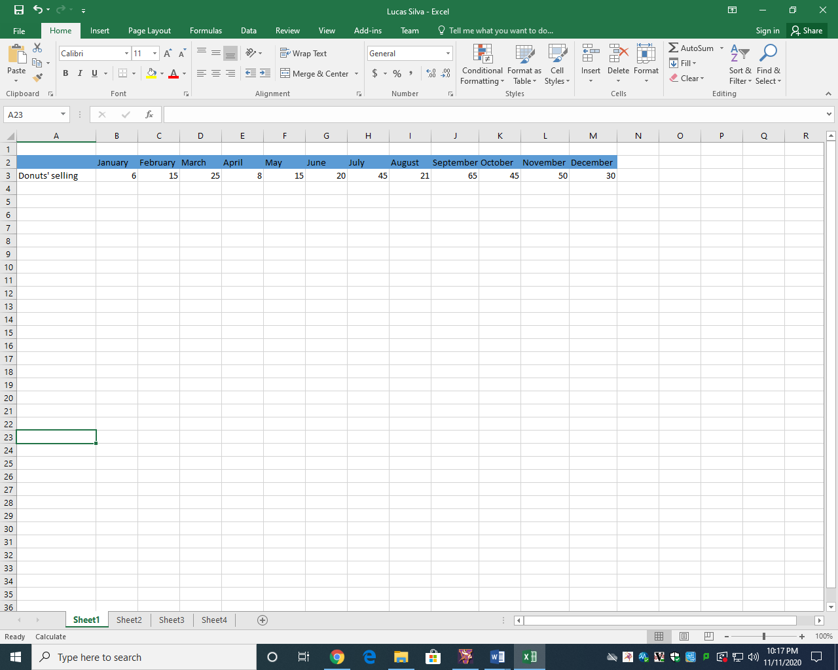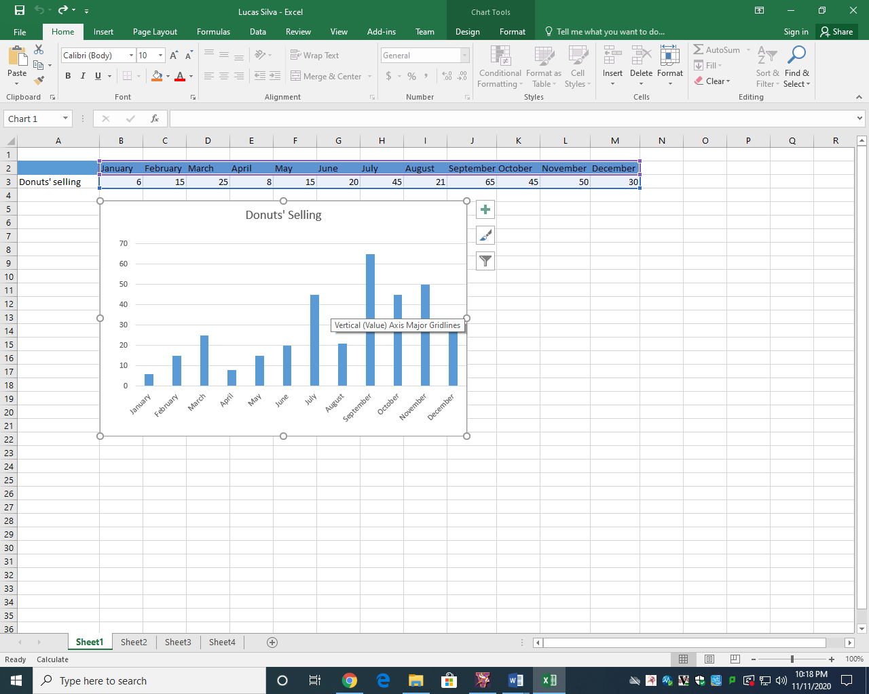

Second Sheet:

1-On the second sheet, I was supposed to choose a topic to base my graphics.

2- After based, I took the data to create the graphic. (Favorite donuts flavor).

3- Then, I started to choose the layout of my sheet and how it was supposed to be organized.

4- I selected my graphic’s type (Pizza Chart).

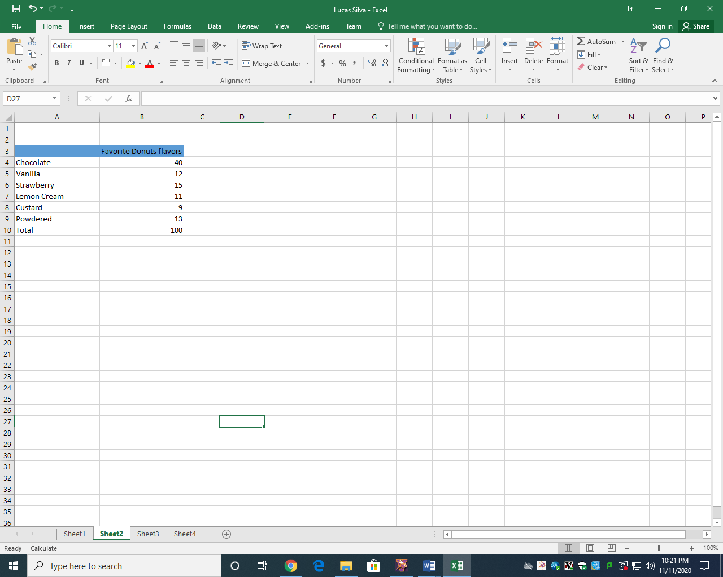 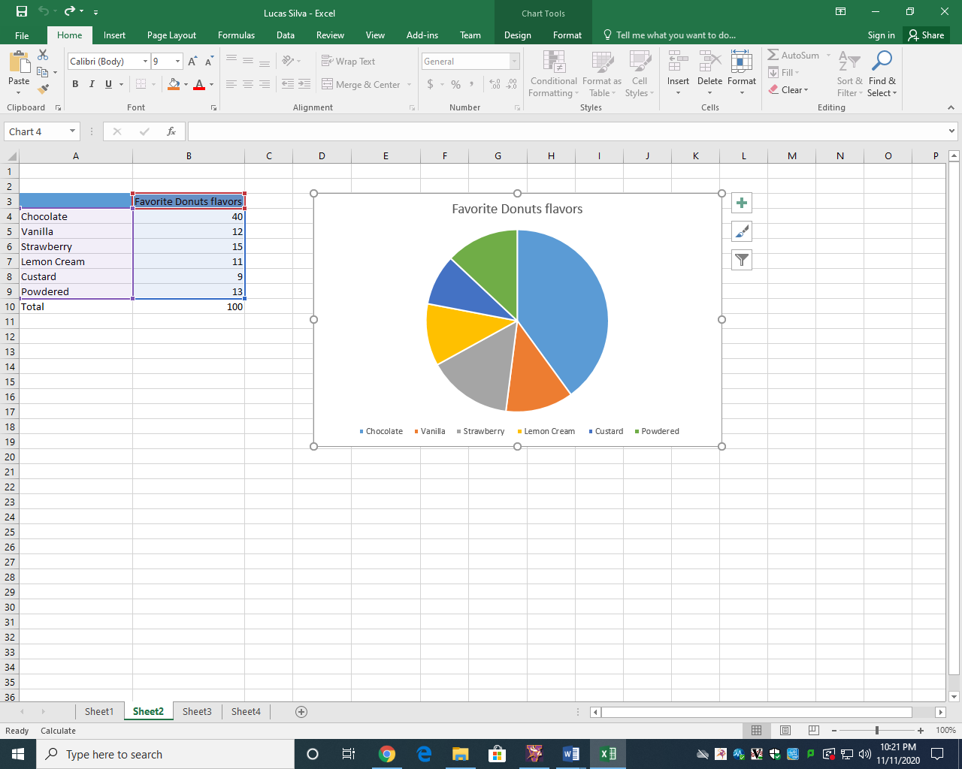

Third Sheet

1- On the third Sheet, I was supposed to choose a topic to base my graphics on.

2- After based, I took the data to create the graphic. (Homework’s per day).

3- Then, I started to choose the layout of my sheet and how it was supposed to be organized.

4- I selected my graphic’s type (line Chart).

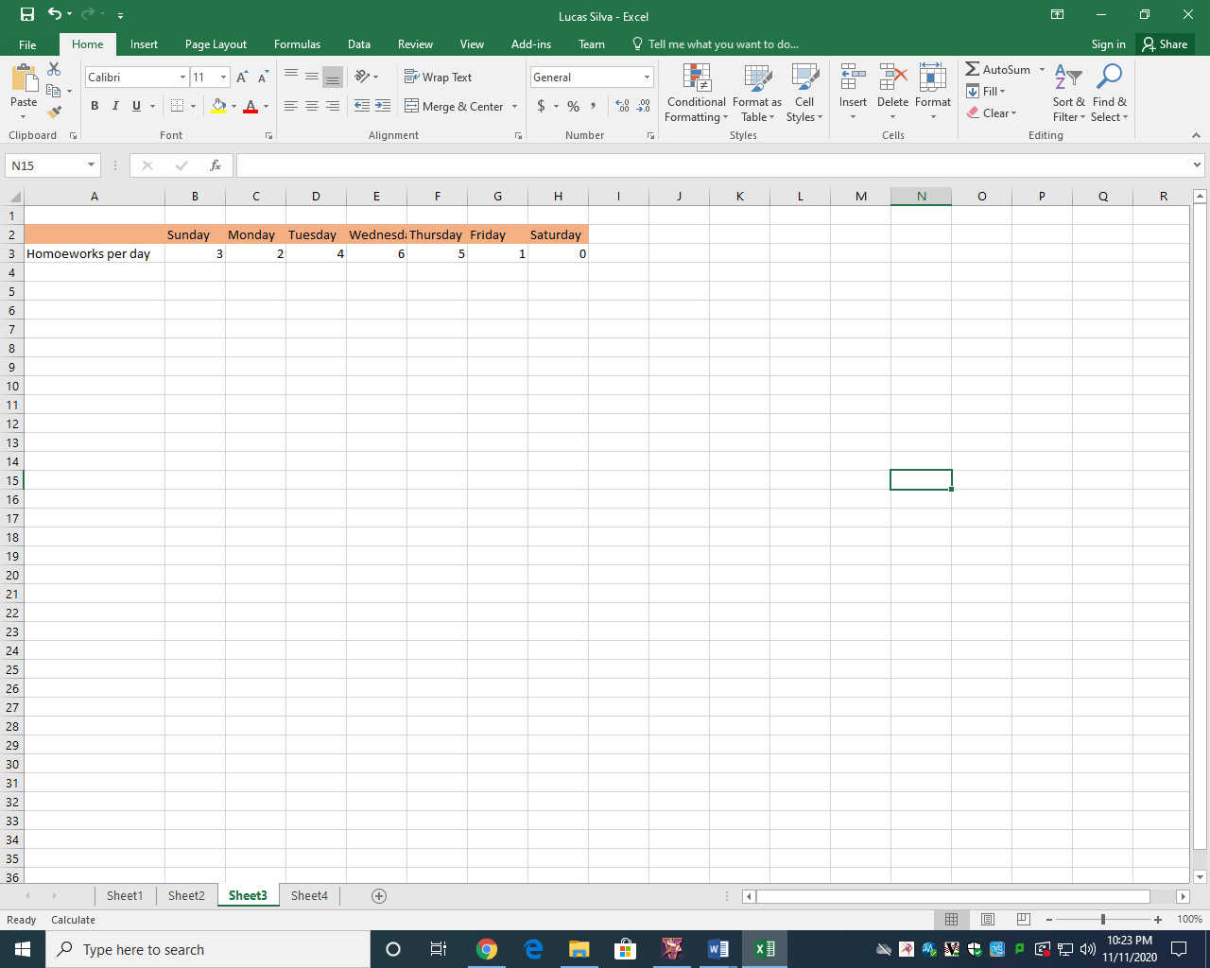 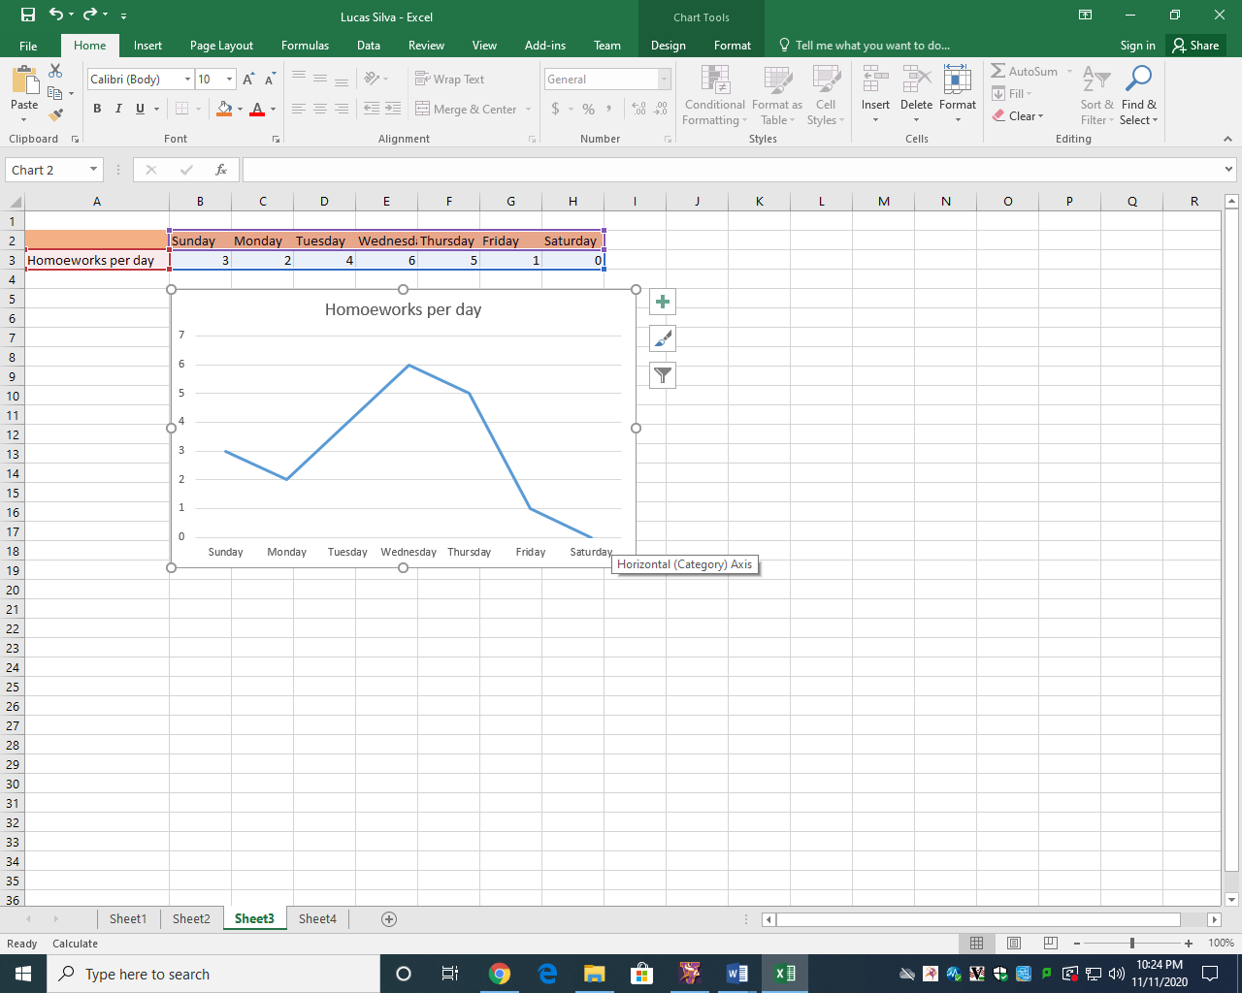

Fourth sheet

1- On the fourth sheet, I was supposed to choose a topic to base my graphics on.

2- After based, I took the data to create the graphic. (People per shoe’s size).

3- Then, I started to choose the layout of my sheet and how it was supposed to be organized.

4- I selected my graphic’s type (Sprinkled Chart).

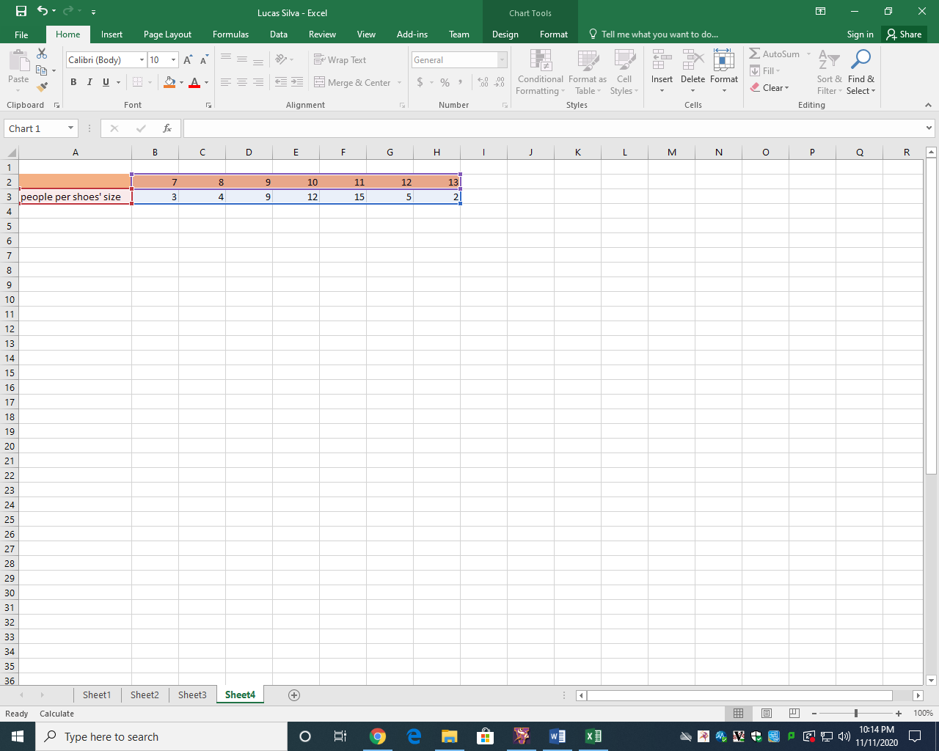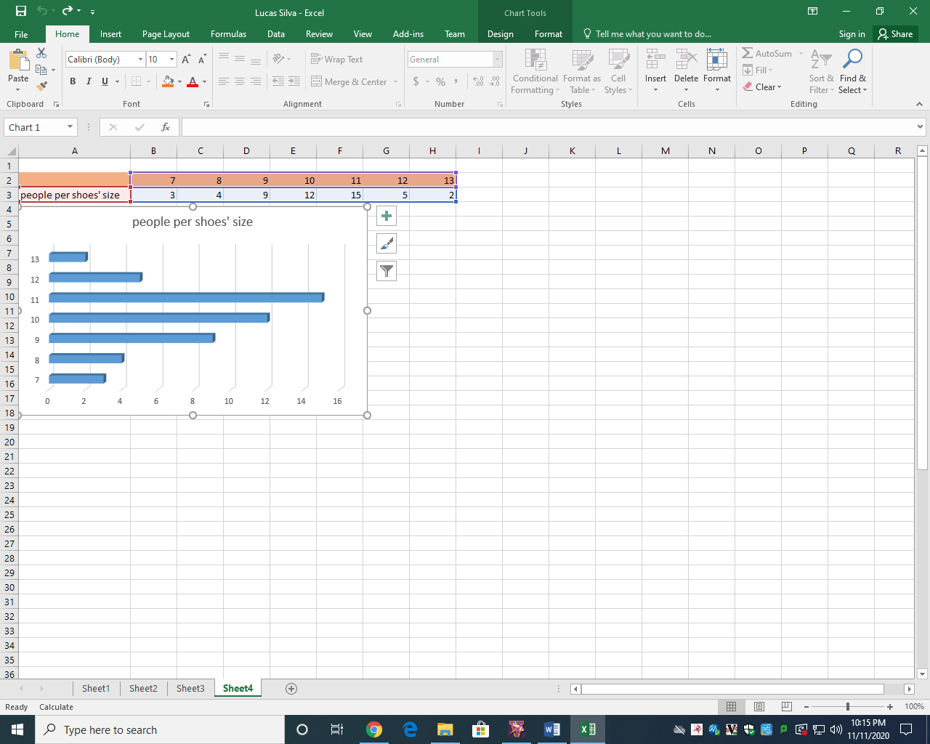

Name: Lucas Pereira Silva

First Sheet:

1- On the first sheet, I was supposed to choose a topic to base my graphic.

2- After based, I took the data to create the graphic. (Donuts’ seeling).

3- Then, I started to choose the layout of my sheet and how it was supposed to be

organized.

4- I selected my graphic’s type (bar’s graphic).

Name: Lucas Pereira Silva

First Sheet:

1- On the first sheet, I was supposed to choose a topic to base my graphic.

2- After based, I took the data to create the graphic. (Donuts’ seeling).

3- Then, I started to choose the layout of my sheet and how it was supposed to be

organized.

4- I selected my graphic’s type (bar’s graphic).

Name: Lucas Pereira Silva

First Sheet:

1- On the first sheet, I was supposed to choose a topic to base my graphic.

2- After based, I took the data to create the graphic. (Donuts’ seeling).

3- Then, I started to choose the layout of my sheet and how it was supposed to be

organized.

4- I selected my graphic’s type (bar’s graphic).

Name: Lucas Pereira Silva

First Sheet:

1- On the first sheet, I was supposed to choose a topic to base my graphic.

2- After based, I took the data to create the graphic. (Donuts’ seeling).

3- Then, I started to choose the layout of my sheet and how it was supposed to be

organized.

4- I selected my graphic’s type (bar’s graphic).

Results

After did this activity, was possible understand more about charts and excel.

Conclusion

### According to that was presented, the Charts got a good and decent aspect, moreover it reached the main goal that was present charts